Dis-Eur-Paleo-Venus-Bulgaria-6th millennium BP- metamorphosed Paleozoic sedimentary rock

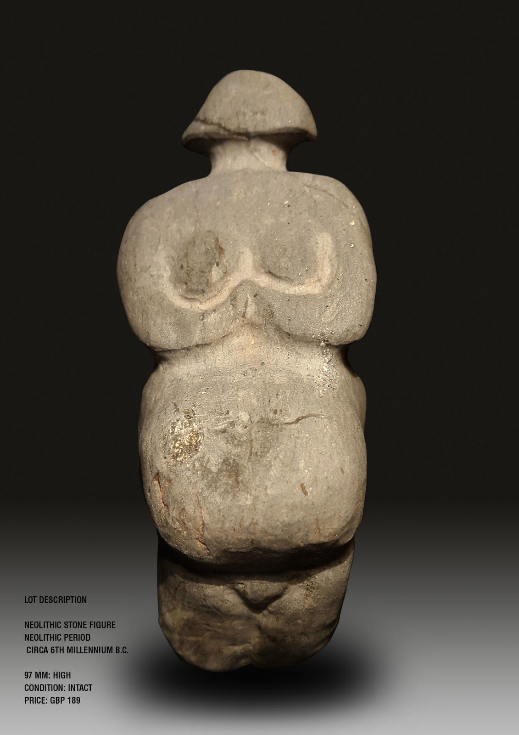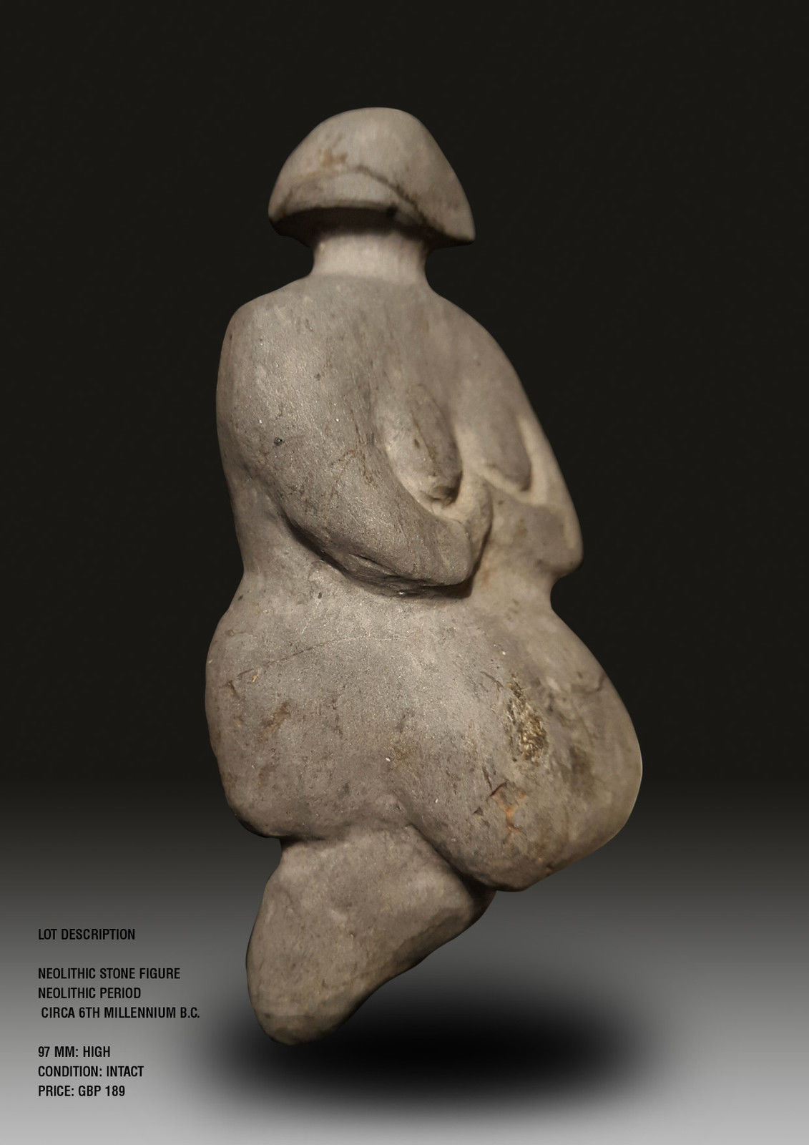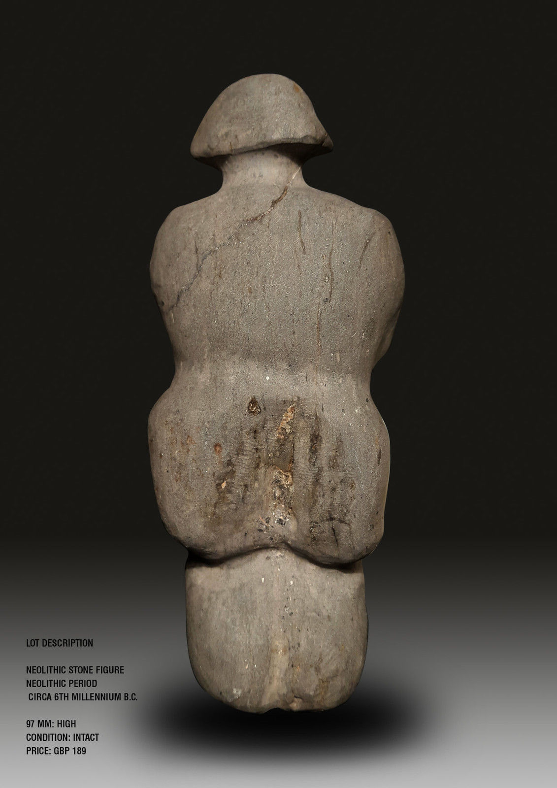

Formal Label:

Accession Number:

Date or Time Horizon: 6th millennium BCE

Geographical Area: Bulgaria, possibly the Balkan Mountains, Stara Planina zone (Foose and Manheim 1975)

Cultural Affiliation: Neolithic

Medium: metamorphosed Paleozoic sedimentary rock (see (Foose and Manheim 1975)

Dimensions: H 97 mm

Weight:

Provenance: Italian Private Collection; then Martin Dimov, Mladost 2, 239/3/3/88 1799 Sofia, Sofia Bulgaria

Reference: Foose, Richard M. and Manheim, Frank. 1975. Geology of Bulgaria: a Review*,* [*AAPG Bulletin*](http://archives.datapages.com/data/browse/aapg-bulletin/) 59(2): 303-335.